**doJAR** steps:

1. Create a new folder under “T24/source/JABLDEV/JARS” with the name of the jar file you want, and create file “routines” inside it

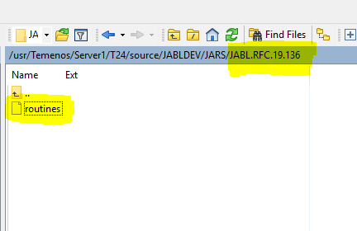

1. Put names of all code files inside (code files which you created under “JABLDEV”)

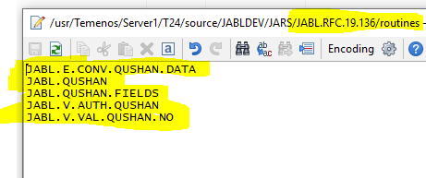

1. Call the command “**doJAR”** with that name of the folder

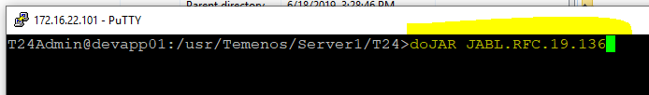

1. Make sure the classes compiled as you want (this will depend on your code if it exists or not and if it has errors in compilation or no)

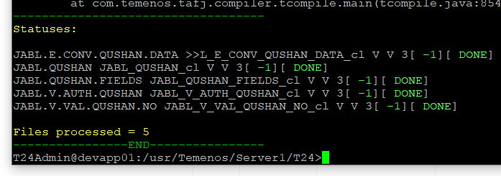

1. Do a refresh to the view of that folder and then you’ll see 2 created folders inside, “JAR” which contains the .jar file, and same name folder that contains all compiled class files

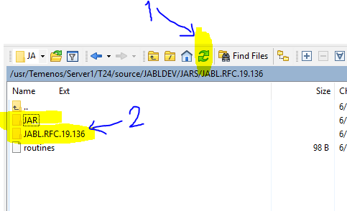

P.S. This automatically sends a copy of the jar file to “T24/lib/LocalDev” for you.